Alexa LoPresti – Lesson for Observation #3
QC TPA LESSON PLAN TEMPLATE

UNIT TITLE: James Rizzi
UNIT GOALS (3):

1. art skills/technique: Students will learn to draw shapes and features to create different characters.
2. art medium/concepts/artists: Students will learn James Rizzi’s art style and how to apply it to their own work.
3. student choice/engagement: Students will learn to make artistic choices in order to create an exciting composition.

LESSON TITLE: Birds
GRADE LEVEL: 4th Grade – Self-Contained
LENGTH OF LESSON: 50 minutes
LESSON OBJECTIVES:

- Students will learn to combine randomly selected characteristics to draw a bird.
- Students will learn how to apply James Rizzi’s art style to their own work.
- Students will learn to integrate their work with their peers’ work to create a cohesive composition.
INSTRUCTIONAL STRATEGIES & LEARNING TASKS
Learning Segments and Pacing: (What will you do in class? What strategies, procedures, and transitions, will you use? What questions will you ask in each segment? Be as specific as possible here. Write out your “script” for what you will say/ask.)

Time | Description of activity
10:50-10:55 – Previous lesson/project reflection  10:55-11:05 – Artist Discussion & Observations  11:05-11:10 – Project Introduction  11:10-11:30 – Student Worktime  11:30-11:40 – Working Discussion | Teacher: Do you all remember the art project we finished last week? What did we draw?  Student: A city!  Teacher: What was special about our cities?  Student: They had faces!  Teacher: Yes, they had faces! What else made this city feel different from a real skyline?  Student: It was very colorful.  Teacher: Yes! You were all able to draw unique faces and choose fun colors for your buildings.  Teacher: This is a tough one… but does anyone remember the artist’s name who inspired our cityscapes?  *If the students don’t remember his name, I will remind them*  JAMES RIZZI!  This is where I will share James Rizzi’s Birds painting.  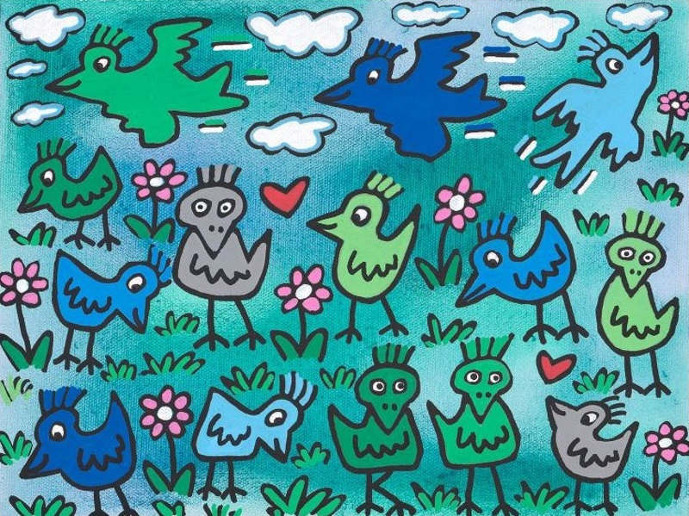  TURN & TALK with a partner. Does this artwork remind you of James Rizzi’s cityscapes? If so, how are they similar?  *Students share-out*  Student responses may include:  - It’s colorful  - They look like birds, but not real birds  - They look cartoony  - It has clouds like the city  - It’s very busy  Teacher: Great! So we can all tell that the same artist who made the cityscapes also made this piece of art?  Students agree.  Teacher: Did you notice the big piece of paper on each of your tables? Does someone want to guess why you don’t each have your own piece?  Student: Are we working together?  Teacher: Yes! We’ll be making a group drawing. And what do you think we’re working together to draw?  Students: Birds!  Teacher: Yes, but we won’t be deciding the characteristics of the bird on our own like we did with the buildings…  We’re gonna have a little help from…  DICE!  *Teacher introduces dice and ‘Roll-a-Rizzi’ worksheet. Teacher demos rolling the dice, locating the corresponding characteristic, and drawing according to the dice roll.  Teacher: Earlier, we talked about how James Rizzi’s cityscapes and birdscapes are very busy and include a lot of buildings or birds! So you can make as many birds as you want! Let’s fill the page as much as possible!  But we will have to be mindful of time because we also want time to color our birds.  I will explain that the students can choose any color for their birds.  When the students receive their Roll-a-Rizzi worksheet, they can begin working on their group drawing.  I will walk around to assess students as they roll their dice and draw their birds.  Since this is a self-contained class with lower learners, I will offer pre-cut bird shapes for tracing. Students will be able to choose if they want to use this support or not.  I will also have the background painted before the lesson, so students can focus on their birds.  Students will continue working on their projects by adding color and background elements (clouds, grass, flowers, etc).  During this time, I will ask students questions to make sure they are thinking about their artwork and how it relates to James Rizzi’s work.  Questions will include:  - How many birds did you draw?  - Which is your favorite bird?  - Does your artwork remind you of James Rizzi’s?  If time allows, I will ask the students to stand up and walk to the other table to view the other group’s work.

INSTRUCTIONAL MATERIALS & RESOURCES: What handouts/worksheets/images/etc. will you use to support your lesson?
- Artwork example by James Rizzi.
- Roll-a-Rizzi worksheet with bird bodies, eyes, legs, etc.
- Pre-cut bird shapes for students who are falling behind or need extra assistance.
- Pre-painted backgrounds on student’s group artwork.
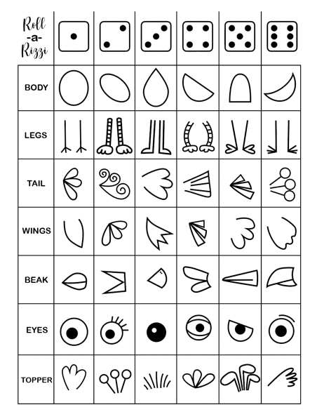
Differentiated Instruction: how will your instructional tasks and supports assist all learners in accomplishing the lesson objectives?
Working as a group will allow students who work faster to fill more of the page, while the students who take their time can focus on drawing only a few detailed birds.
I understand that some students are not confident in their ability to free-draw the shape of a bird, which is why I will be prepared with pre-cut bird shapes to offer as an alternative option.
I will also have pre-colored backgrounds on the students’ work so they can spend their time focusing on the drawing of their birds and other elements.

LESSON ASSESSMENT: How will you know if students mastered the objectives?
Formative (in process) Assessment: Formative assessment can help you understand students’ prior knowledge or can happen as you go and is used to help you focus your teaching.

Formative Assessments will be conducted through the Turn & Talk, and the responses students give in the working discussion at the end of the period. I will also formatively assess students as they are drawing their birds. Working well as a group is also something I will be observing.

Summative (at the end of the lesson) Assessment: Summative assessment comes at the end of the lesson. For each objective, how will you determine what/if students are learning what you hope to teach? What evidence would you collect to show that students are learning/mastering each objective?

For the summative assessment, I will collect the group drawings to make sure students:
- Took inspiration from James Rizzi and applied it to their work.
- Drew multiple birds and other elements to “busy” their artwork.
- Used creative thinking to arrange and color their birds.

