Alexa LoPresti – Lesson for Observation #1
QC TPA LESSON PLAN TEMPLATE

UNIT TITLE: Mosaics
UNIT GOALS (3):

1. art skills/technique: Students will learn how to arrange and glue cut paper to create a mosaic-like composition.
2. art medium/concepts/artists: Students will learn what a mosaic is through the introduction of artist & architect Antoni Gaudi.
3. student choice/engagement: Students will learn to create a dynamic composition through their choice of colors and shapes.

LESSON TITLE: Fall Leaves
GRADE LEVEL: 4th Grade Self-Contained
LENGTH OF LESSON: 50 minutes
LESSON OBJECTIVES:

- Students will learn how to arrange and glue cut paper to create a mosaic-like composition.
- Students will learn what a mosaic is through the introduction of artist & architect Antoni Gaudi.
- Students will learn to create a dynamic composition through their choice of colors and shapes.

INSTRUCTIONAL STRATEGIES & LEARNING TASKS
Learning Segments and Pacing: (What will you do in class? What strategies, procedures, and transitions, will you use? What questions will you ask in each segment? Be as specific as possible here. Write out your “script” for what you will say/ask.)

Time | Description of activity
10:50-10:55 – Opening discussion about mosaics  10:55-11:10 – Introduce Antoni Gaudi and his work  11:10-11:20 – Introduce project & demo  11:20-11:40: Students work | Teacher: Has anyone ever heard of the word mosaic?  If students don’t reply…  Teacher: Did you know a mosaic is a style of art?  1 or 2 students may say yes or nod their heads. Students might raise their hand and speak about prior knowledge.  Teacher: What if I showed you this image and told you this was a mosaic?  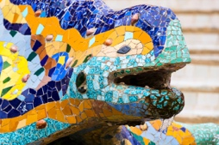  TURN & TALK with a partner about what you notice about this work of art.  Teacher: What did you notice about this image?  Student responses may include:  - It looks like a lizard  - It’s very colorful  - It looks like broken glass  - It’s made of a bunch of tiny pieces  Teacher: I love all of these observations! Yoel mentioned that it looks like broken glass, and Hazel said it’s made of a bunch of tiny pieces… do you know what those tiny pieces are?  Teacher: They are tiles! And they are made of glass. Artists call them “tesserae”.  Teacher: So now that we’ve seen an example of a mosaic, can anyone tell me what a mosaic is?  Student: Art made of glass/tiles.  Teacher: Yes! Let me show you some other examples… All of these mosaics were created by a Spanish artist/architect named Antoni Gaudi. And these images are mosaics from Park Güell in Barcelona.  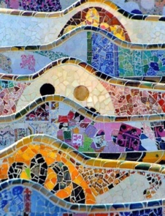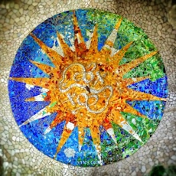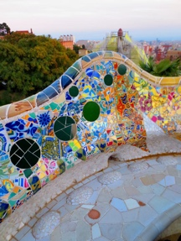  Did you know Ms. Esposito, Ms. Veljacich and I went to Barcelona and visted Park Güell together!? If we can get through this lesson with the best behavior and finish our project in time, I’ll show you a picture of us at Park Güell!  Teacher: Speaking of the project…we are going to make our own mosaics! And since it’s fall, I thought it would be fun to use fall colors and make leaves!  Show project examples:  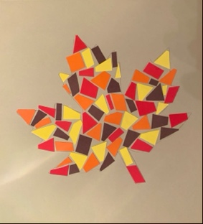 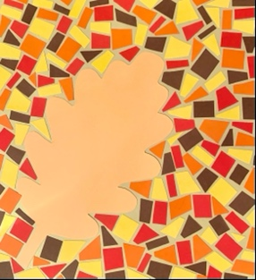  Project A. Project B  Teacher: How is my project similar to the examples we just saw by Antoni Gaudi?  Student: Yours looks like tiles.  Teacher: It does! But what materials am I using instead of glass?  Student: Paper!  Teacher: Yes! You will be using cut paper to look just like tiles in a mosaic.  Teacher: Do you notice anything about how I arranged by paper tiles?  Possible student responses:  – You use a lot of different colors  – You glued the pieces close together  Teacher: Yes! I love that Cristian noticed that my tiles are placed close together. But am I overlapping them???  Students: No!  Teacher: Am I leaving HUGE gaps between my tiles?  Students: NO!  Teacher: Exactly! I’m creating a background or a shape by placing my tiles close together, but not overlapping them. Let me show you quickly how I started my project.  *Teacher demos how to apply glue to each piece. Teacher shows how she decides on what color/shape tile to use. Teacher shows how she arranges them to start creating the background/shape.  For example, I will give suggestion such as:  – Apply glue stick to the canvas first, and then add the cut paper.  – You can cut the already cut pieces to make them fit better if you need to.  Teacher: I will be passing around cut leaves for you all to choose from! You can either trace the leaf and create your mosaic within the leaf like Project Example A, OR you can glue down the leaf and create your mosaic around it like Project Example B!  Students begin working on their project as I walk around to observe and make sure students are applying what they learned during the lesson. If students finish early, I will suggest that they add cut paper to the background, if they chose Project A, and vice versa if they chose Project B.

INSTRUCTIONAL MATERIALS & RESOURCES: What handouts/worksheets/images/etc. will you use to support your lesson?
- When I introduce mosaic artist Antoni Gaudi, I will show examples of their work such as, Park Güell in Barcelona, Spain.
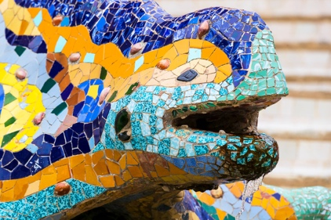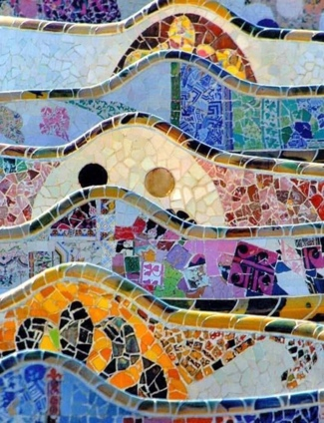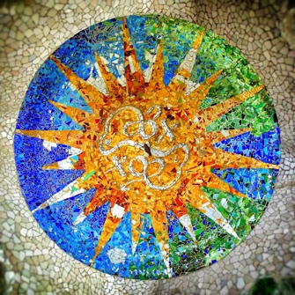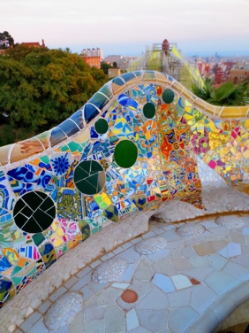
- I will provide 2 different project examples that I created previously, to show the students what they will be creating, and to give them a choice of how they will create their mosaic.
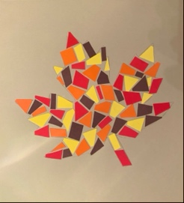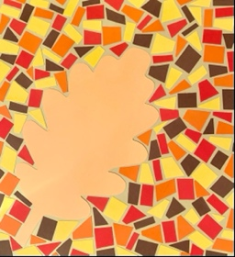
- I will demo ways to properly glue the cut pieces of paper.
- I will provide pre-cut pieces of paper for the students to use in their mosaics.
Differentiated Instruction: how will your instructional tasks and supports assist all learners in accomplishing the lesson objectives?
I understand that some of my students may work faster than others, and other students may need extra support to complete the assignment. For my lower learners, I will recommend they glue down an entire leaf silhouette and create the mosaic around the leaf. For my students who may want a challenge, I will suggest they create a mosaic of the leaf and of the negative space around the leaf, as well. Because this is a self-contained class, I will pre-cut the paper (mosaic tiles).

LESSON ASSESSMENT: How will you know if students mastered the objectives?
Formative (in process) Assessment: Formative assessment can help you understand students’ prior knowledge or can happen as you go and is used to help you focus your teaching.

Formative Assessments will be conducted through the Turn & Talk, and the responses students give during the discussion. I will also assess the students as I walk around the room during work time to see if the students are applying what they learned in the lesson.

Summative (at the end of the lesson) Assessment: Summative assessment comes at the end of the lesson. For each objective, how will you determine what/if students are learning what you hope to teach? What evidence would you collect to show that students are learning/mastering each objective?

For the summative assessment, I will collect each students’ mosaic project. I will determine if each student met the objectives by:
- Seeing if the students arranged their paper in an interesting way, without overlapping, possibly creating a pattern-like composition.
- Comparing the students’ work to the examples shown in class, to see if their work was inspired by Antoni Gaudi.
- Seeing if students were thoughtful with their choices of the cut paper, considering color and shape.

